Business Analytics (MBR2070T)

Name: Dipayan Saha Course: MBA
Section: 2 Roll No.: 71
Assigned by: SVC Due Date: 02/03/2025

Identification of the Objectives:
Promoter's Perspective:
- Maximizing Profit: Determine which house features (e.g., sqFt, bedrooms, bathrooms, brick exterior, or neighborhood) correlate with higher sale prices to focus marketing efforts or set pricing strategies.
- Understanding Market Trends: Assess how the number of offers relates to price, as this could indicate demand and competition levels affecting sale outcomes.
- Identifying Sellable Features: Identify features associated with higher demand (e.g., via offers or price premiums) to prioritize in listings or developments.

Buyer's Perspective:
- Finding Best Value: Identify houses or neighborhoods offering the most area with respect to the money.
- Understanding Feature Costs: Quantify how much additional bedrooms, bathrooms, or a brick exterior increase the price to evaluate trade-offs.
- Assessing Market Competition: Examine how the number of offers influences price to gauge competition and negotiate effectively.

- Scatter Plot of Price vs. Area (SqFt.) with Regression Line
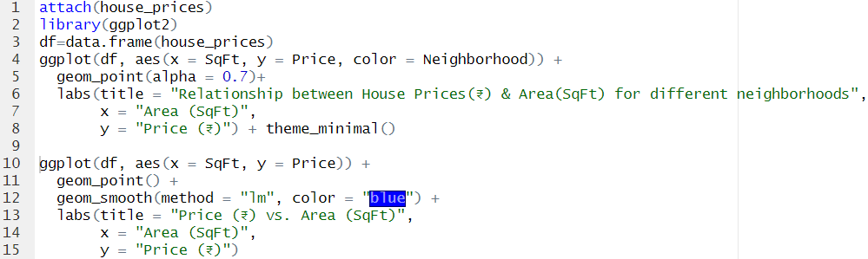
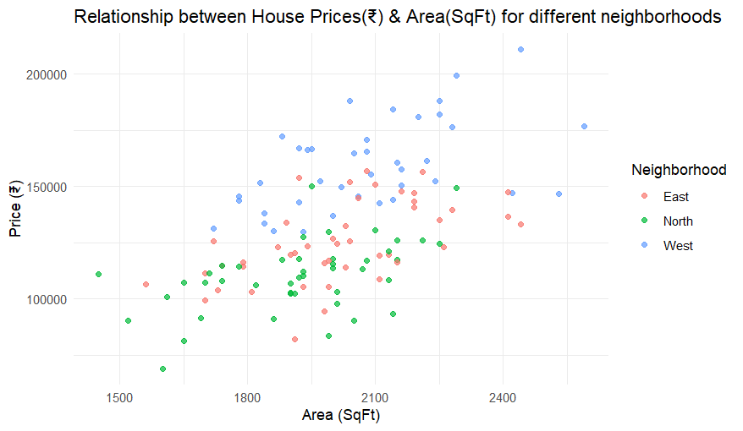
- There’s a general positive correlation between house price and area (square footage).
- Larger homes tend to have higher prices.
- West (Blue): The blue points are generally clustered toward the higher price range, especially for larger areas. This suggests that homes in the West neighborhood are typically more expensive, possibly indicating a premium or wealthier area.
- East (Orange): The orange points are spread across a moderate price range (e.g., ₹100,000–₹160,000) and cover a wide range of areas. They appear to have a mix of lower and higher-priced homes, but fewer reach the highest prices compared to West.
- North (Green): The green points are mostly concentrated in the lower to mid-price range and smaller to medium areas (1,500–2,200 SqFt). This indicates that North is likely the most affordable neighborhood, with fewer expensive or large homes.

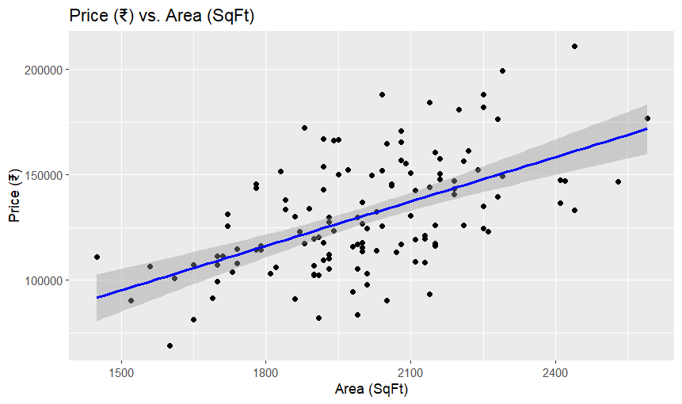
This graph shows a positive trend, with price increasing as area grows. The regression line indicates the average price increase per square foot. For promoters, this highlights the value of larger homes; for buyers, houses below the line may represent better value.

- Box Plot of Price by Brick Exterior
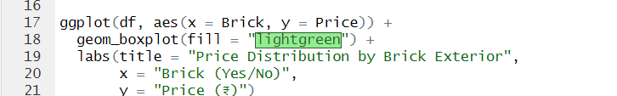

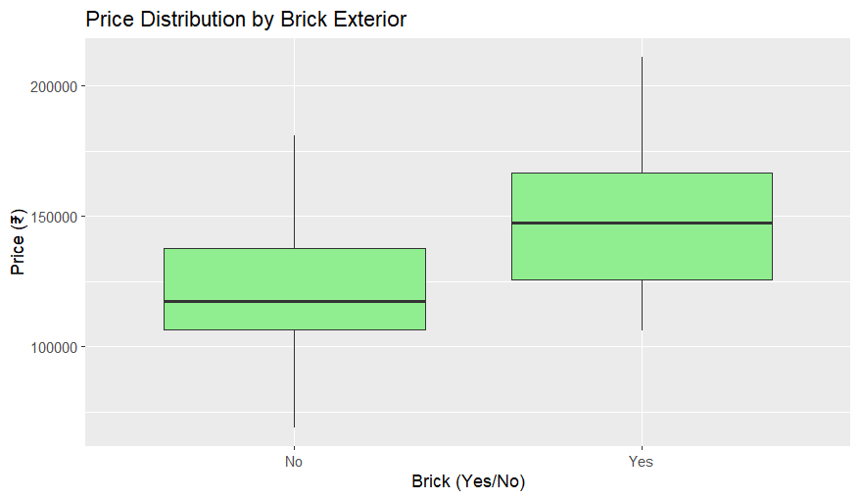
Houses with brick ("Yes") may have a higher median price. Promoters can emphasize brick exteriors; buyers can assess if the extra cost aligns with their preferences.

- Bar Plot of Price by Number of Offers
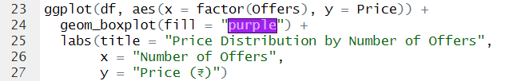
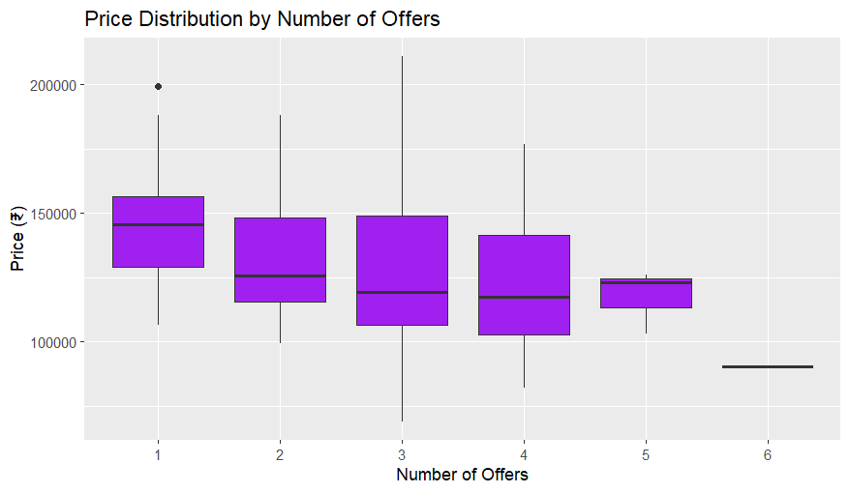

Median prices might decrease slightly with more offers, suggesting competition drives prices down for affordable homes. Promoters can gauge demand; buyers assess competition intensity.
- Boxplot of Neighborhood vs Price
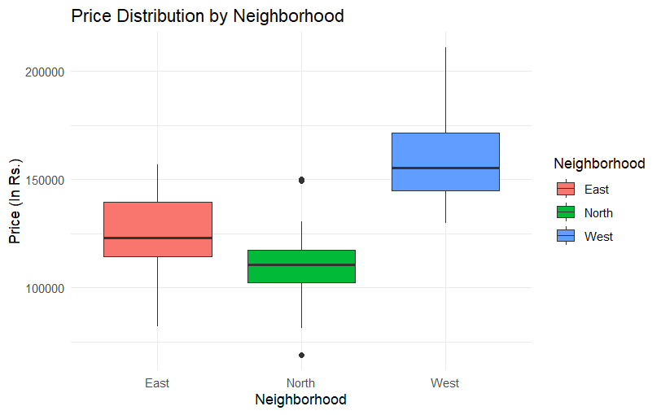
- West (Blue): The median price (the line inside the blue box) is the highest, approximately ₹160,000–₹170,000. This indicates that homes in the West neighborhood are, on average, the most expensive.

- East (Red): The median price for East is lower, around ₹120,000–₹130,000, suggesting it’s a mid-range neighborhood in terms of price.

- North (Green): The median price for North is the lowest, approximately ₹100,000–₹110,000, indicating it’s the most affordable neighborhood.

- Prices in West are skewed toward higher values, with the median and upper whisker reaching up to ₹200,000, indicating a premium market.

- East and North have lower median prices and narrower ranges, with North being the most affordable and least variable.

- The outlier in North suggests some variability or premium properties even in an otherwise affordable area.

- Boxplot of No. of Bedrooms vs Price

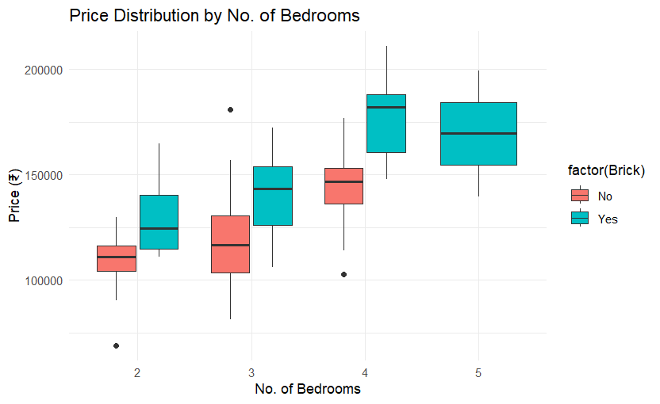

- Across all bedroom counts, homes with a brick exterior (blue) consistently have higher median prices than non-brick homes (red). The difference is most pronounced for 3 and 4 bedrooms
- For 2 bedrooms, the difference is smaller, and the boxes overlap significantly, suggesting less of a premium for brick in smaller homes.
- For 5 bedrooms, the difference narrows, possibly due to fewer data points.
- Prices increase with the number of bedrooms, as expected in real estate markets. The jump from 4 to 5 bedrooms is particularly visible, suggesting a premium for larger homes.
- Brick exteriors consistently add value, but the premium diminishes slightly for 5-bedroom homes, possibly due to other factors (e.g., location, area) overshadowing brick status.

- Histogram of Average Price(₹) per Area (SqFt)

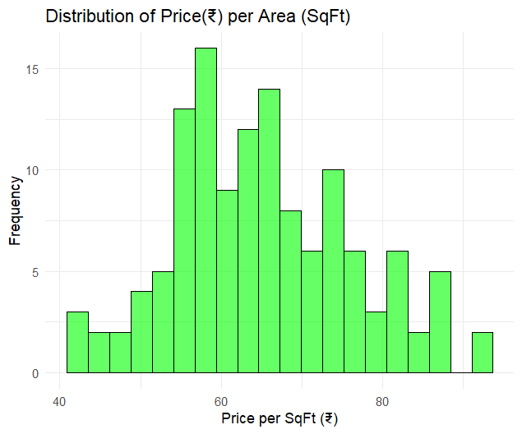
- The histogram is right-skewed (positively skewed), meaning most houses have a lower price per SqFt., with fewer houses having higher prices per SqFt.
- The highest frequency bar is around ₹50–₹60/SqFt, with a frequency of approximately 14–15 houses. This suggests that the majority of homes in the dataset fall within this price range per SqFt.
- Beyond ₹70/SqFt, the frequency drops sharply, with only 1–2 houses at ₹70–₹80/SqFt, indicating that very few homes have a high price per SqFt..
- The mode appears to be around ₹50–₹60/SqFt, suggesting this is the typical price per square foot for most houses.

